**Student Performance Dataset**

The dataset chosen relates to education industry where student’s performance is assessed along a variety of their background attributes. The attributes include student demographic, social, school-related features, and their grade achievements. The data are collected using questionnaires and school reports of a Portuguese school. The participants age 16 – 21 who have done their papers had their grades captured individually.

**Columns Description**

There are a total of 31 columns. The dataset comes with student’s parent jobs, parents’ education level, student social life such as alcohol consumption, family relationship, going out frequency, absent from class and their grades.

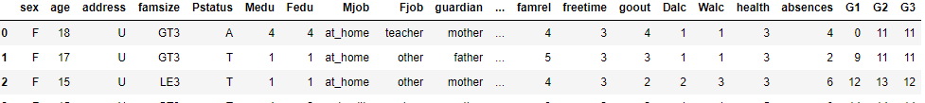

**Getting Insights from Data**

The overarching question motivating this research: Do students performed better in academics if their family background has a higher education level and career roles. Not limited to that, the study of this dataset can focus on whether staying together with family or apart influence student’s grade. It is also possible to look into student’s social life outside of school in terms of romantic relationship, going out often, which may potentially affect the grades.

**Project Brief and Problem Statement**

At the core of understanding student academic achievements in revealing specific inequalities of the student’s family background. The presence of family background and the student social life can be valuable predictors in how well the student perform in school.

In early assumption, the researcher or anyone would assume that parents with higher education and better career could lead their child to stronger academic achievements. This may or may not be the truth and this analysis is to back up the claims or rather find the evidence.

The researcher aims to determine if there is any significance different between student’s grade and the correlation to the family background and social life. The angle is that student bring their family experiences with them to school, so teachers need to have a better understanding of their student’s background and how they function. The more effort in understanding student’s problem may lead to better academic achievement of students. Teachers could benefit from this analysis, make better decisions in managing student, and help student achieve greater.

**7 Questions**

* Identify the top 10 students who strive in academic based on the final grades

Based on the top 10 achievers, we can quickly grasps the idea of what kind of environment do this student belongs to. If it is a mix of poor and good background, then these insights offer to look deeper into student social life.

* Identify bottom 10 students who failed or who performed badly based on their final grades.

To figure out why those students performed badly and the possible reasons/factors explanation behind. Why they struggling and what are their grades for the period of early-term, mid-term and final exam.

* Which factors has the most/least influence on academic achievement?

To gain deeper understanding, to find out the factors that has the most beneficial or detrimental to the academic outcome.

* Does study abroad link to better or poor academic performance?

This is to measure the impact of studying abroad by taking top 10 achievers and the bottom 10 to compare and how many students are studying abroad to arrive the conclusion.

* Does parents’ education level matters that influence student grade?
* Identify students with the highest and lowest absentees in school and compare their grades.
* Identify students who have poor/better family relationship and compare their grades.

These are preliminary questions which later stage may have more questions raised in the effort of establishing the connections between the variables.

**Limited Findings**

Several limitations should be noted. Given that the selected dataset is only to conduct the above methodology and limited to assess the quality of education delivered by the school, parenting style and student’s personality or talent.

Since the students (samples) enrolled into the same school, the researcher notes that all student received the same quality of education therefore justifying the student’s background is for the purpose of this research.